EXHIBIT/P-00100

PRESENTATION

TO

OFF-SHORE HELICOPTER SAFETY INQUIRY

established by
Canada Newfoundland and Labrador Off-shore Petroleum Board (CNLOPB)

Honourable Robert Wells, Q.C.
Commissioner

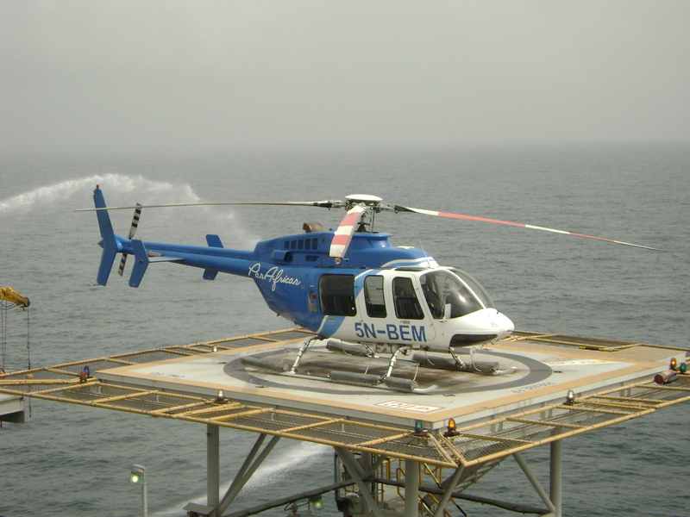
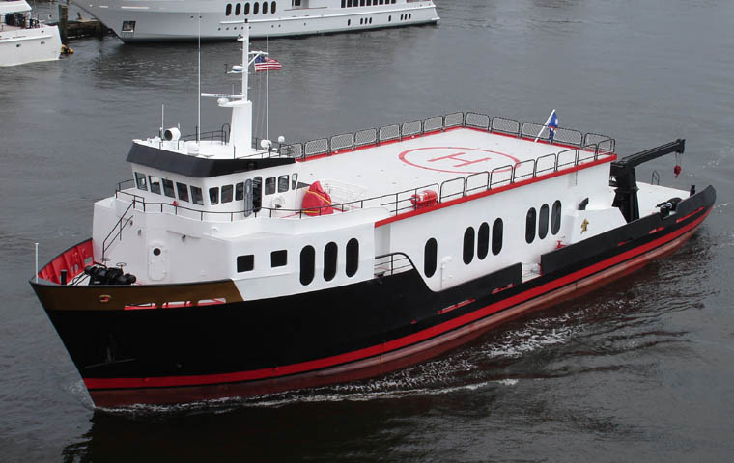

Submitted by:
William A.(Bill) Parsons
Retired Labour Leader

YOUR HONOUR

It is indeed a pleasure and an honour to have this opportunity to appear before this Offshore Helicopter Safety Inquiry. Needless to say, I was impressed with the Commissioner’s first press conference and I quote from the Telegram:

“Speaking to the media, Wells said he has already been in contact with other countries that have offshore oil industries, Norway, the United Kingdom and the United States and said he expects them to take part in the Inquiry,

However, Newfoundland’s conditions are somewhat worse.

The North Sea can be a rough place, but it hasn’t got ice and frigid waters like we have. The Gulf of Mexico, baring the hurricane season, is a much calmer place than the North Atlantic”.

Wells said “It seems that, in one sense, we have ice, we have frigid waters, and we have high winds and cold - and all that plays a part in safety.”

First, I would like to express my most heartfelt sympathy to all those families, spouses, friends and extended families, to all those mourning the loss of their loved ones in this terrible crash at sea of Cougar Flight 491 on March 12th of this year.

During my working career in the labour movement, many times - all too often - On occasions I have had the experience of attending workplace fatalities, injuries and diseases. Workers taken away so suddenly and tragically at the workplace changes lives forever.

Secondly, I express unequivocally, my deep appreciation to Mr. Robert Decker, the sole survivor of Cougar Flight 491 for putting a “human face” to the events moments prior to the ditching, his immersion into the icy waters of the North Atlantic and his actions which brought him to the surface - his survival. I wish him well in his recovery. He has provided this Inquiry with loads of information and life experiences that the Commission would not have had otherwise.

This presentation will speak to four basic issues which I would submit to this Commission.

- The role of the Canada Newfoundland and Labrador Off-Shore Petroleum Board (CNLOPB) in matters respecting workplace occupational health and safety.
- The need for effective legislation and regulation for “Off-Shore” workplaces.
- The definition of “worker” or “employee” in the “Off-Shore” workplaces.
- A mid-distance Heliport.

The role of the Canada Newfoundland and Labrador Off--Shore Petroleum Board (CNLOPB) in matters respecting workplace occupational health and safety

This is an extract from a story called “OCEAN RANGER TRAGEDY RAISED SAFETY ISSUES”, Special Report - Saturday, February 16th, 2002 - The Telegram.

Offshore safety is regulated by the Canada-Newfoundland Offshore Petroleum Board (CNLOPB). The board was created to manage the resource in 1985 by the federal and provincial governments, as part of the Atlantic Accord.

The CNLOPB employs eight staff members dedicated to safety issues. They examine industry processes and training, traveling offshore to conduct an audit roughly every two months.

They also monitor reports submitted daily by operators about the progress of drilling and production activities. Operators are required to notify the CNLOPB of any incidents.

“The purpose there is to reduce the risks to as low as reasonable practical,” says Howard Pike, the CNLOPB’s manager of operations and chief safety officer. “You can never eliminate risk. It’s just a part of life. There’s always a risk in everything you do. So the whole notion there is to bring it down to the lowest degree possible.”

Although the CNLOPB relies on off-shore operators to provide it with information, Pike is confident nothing is being hidden from the board.

“There is a legislative requirement for them to do this,” Pike says. “And if we catch them not doing it, then we lay charges against them. If you look at the Hibernia platform, there are 220 people on board. I can assure you that if somebody doesn’t like what they see going on, they will normally find a way of letting us know.”

(In the fall of 2001, Hibernia became the first offshore oil platform in North America to become unionized; Hibernia Management Development Co. is challenging that certification.)

Operators who breach a work authorization - which is necessary to operate in the offshore - can be charged with an offence, Pike says. Summary convictions can net a $100,000 fine or one year in jail; more serious indictable offences carry a possible fine of $1 million.

The CNLOPB has only ever laid two charges, both against divers - One for using a falsified certification, the other for providing doctored diving logs.

Pike says the lack of charges against industry heavyweights means the CNLOPB is doing its job. To make his point, he draws an analogy to highway safety.

“If we were regulating highway safety the way we regulate the off-shore, what would happen is before you’d be allowed to take that trip to Gander, you’d have to make an application,” he says.

“And then what we would do is sit down and say ‘OK, what inspections have you done on the car? Are the brakes good?”…So you would check the appropriateness of that vehicle for that drive.”

Once the car had cleared all those hurdles, the driver would have to file regular reports. And the CNLOPB might decide to station somebody at Goobies, just to make sure the driver was following the rules of the road.

“So it shouldn’t be surprising from that standpoint, if we’re doing it that way, that we wouldn’t be issuing as many speeding tickets,” Pike says.

While the CNLOPB regulates safety, it doesn’t make public the details of its investigations.

The agency is bound by the Atlantic Accord Act, which includes a confidentiality provision specifying what information can be released. “So we’re working with the legislation,” Pike says.

While critics have railed against at the CNLOPB’s perceived lack of transparency, Pike says the confidentiality arrangement allows off-shore operators to be frank with safety personnel.

Right now we get, I would say, very candid descriptions of the processes going on. So we’ve got the issue of confidentiality from a business perspective - a business’s right to confidentiality versus the public’s right to know.”

The CNLOPB currently enforces a combination of the provincial Occupational Health and Safety Act and draft legislation targeted specifically at the offshore - a situation, Pike allows, that does lack some clarity.

The offshore component of occupational health and safety legislation has been in draft form since 1989.

Joint action by the provincial and federal governments is necessary for the 13-year old draft legislation to officially come into effect.

“We don’t promulgate the regulations; we only enforce them, we administer them,” Pike says. “It is up to the governments to promulgate these regulations.”

Clarity of regulations aside, Pike acknowledges that the CNLOPB needs industry co-operation to do its job.

“Safety per se can’t be legislated. This has to be something that people do of their own accord. We’re being very proactive in this regard; we’re trying to get them to act safely all the time, not just while we’re there.”

And making such changes can have meaningful results.

“As is indicated in the Ocean Ranger report, it’s a sequence, frequently, of events. All you need to do to stop an accident is get one of those dominoes out and that stops the sequence.” - end of quote.

During the period of the Ocean Ranger Disaster, there were numerous questions arising i.e. which has jurisdiction, the federal government or the provincial government? Was the Workers Compensation Act applicable? Was it responsible for death benefits etc? With the1985 Atlantic Accord the provincial government, under certain conditions, was given jurisdiction of occupational health & safety legislation standards and regulations. Something the provincial Department of Occupational Health & Safety never did achieve because of provincial/federal conflict on the issues of occupational health & safety regulations and standards. The CNLOPB assumes the role of enforcement of the occupational health & safety off-shore. It is, according to the CNLOPB, a combination of the provincial occupational act and draft legislation targeted specifically at the off-shore, a situation the CNLOPB states lacks some clarity.

This situation, in time, is a disaster waiting to happen. The CNLOPB is a federal/provincial crown corporation with its main objective being to sell resource oil and gas land at a sustained profit with certain restrictions to the oil and gas corporations. The CNLOPB controls the issuing of licenses for exploration and development by which mode and with which amount of production. The oil and gas corporations have a greater budget than any nation in the world. These corporations’ main objective is solely to return profits to their shareholders.

The CNLOPB has a budget to administer and therefore has, as its objective, a specific funding amount of cash for occupational health & safety. No other country sources-out its workplace health and safety to other corporations, with the exception of Norway.

The Government of Norway has “The Norwegian Petroleum Directorate”. This authority has a very specific legislative mandate for “all aspects” of the workplace environment health and safety”. It answers directly to the ministry responsible for off-shore oil and gas workplace health and safety.

I’m confident the Commission is aware of its volumes of legislative law and statutes and regulations relative to those matters.

In comparison, the CNLOPB and the Norwegian Petroleum Directorate respecting workplace health and safety - there is frankly none. Absolutely.

The need for effective legislation and regulation for off-shore workplaces

It is my view that not one, not one ministerial department, federal or provincial, has taken ownership or responsibility legislatively for the occupational health and safety for the off-shore workplace.

Following this Inquiry via the media, it is most difficult to follow what statutory body bears the ultimate sole responsibility for off-shore petroleum workplace, workers health and safety. There is, to the best of my knowledge and belief, not one such single authority, nor is there no authority which coordinates such an effort. As a matter of fact, the CNLOPB has no statutory regulatory authority on occupational health & safety.

According to the CNLOPB, It starts with a safety plan, which is required by all oil companies working in the Newfoundland and Labrador off-shore industry. Those plans explain how the companies will keep their employees and those of their contractors’ safe, both in the workplace and while traveling to and from the off-shore platforms and drilling rigs. All safety plans are submitted to the CNLOPB for approval.

I quote from the Telegram, which the Telegram said is part of the evidence before this Commission.

“In the process of reviewing a safety plan, we review the helicopter operations,” said Howard Pike, chief safety officer for the CNLOPB.

“That includes the helicopter systems and equipment, emergency response training and how the operator supervises such contracts.”

The board also monitors compliance with those safety plans, which Pike said are designed to “manage risk for the protection and safety of the people working off-shore.”

“We verify that operators follow those plans…and we verify that deviations from approved plans are corrected,” he said.

“Safety of an activity requires three elements - the appropriate equipment, the proper procedures and competent personnel.”

Operators are defined as anyone holding an authorization permit issued by the CNLOPB to carry out offshore activities, such as drilling wells, diving or producing oil.

Authorizations are essentially work permits and they are primarily held by the oil and gas companies.

A helicopter company, for instance, is not considered to be an operator - it’s a contractor hired to transport workers.

While the CNLOPB does not directly oversee contractors’ activities, John Andrews, legal manager for the board, said transportation is included in any operator’s safety plan.

He also said the operators - not the offshore board - are responsible for worker safety.

“These are not the board’s safety plans. These are the operators’ safety plans. We are verifying that appropriate safety plans are in place.”

Andrews said the board carries out audits and inspections to ensure the operators follow those plans.

“The board does not have the responsibility for safety. It has an interest in safety of workers by way of its oversight role and its verification role, but worker safety is the responsibility of operators.”- end of quote.

In the workers world of work, if an accident or fatality or other incident happens, who would the worker feel more impartial - the management safety representative, a CNLOPB safety representative or occupational health & safety representative from his or her elected government department.

Occupational Health and Safety Legislation, Regulations, Standards should, as to the greatest degree possible, be a multi-party effort. Legislation enables and provides for regulation, standards, personal protective clothing and equipment, risk analysis, job processes and procedures, lockouts, fall arrests, imminent danger, confined spaces, transportation, workplace committees, training and the list goes on.

Regulation should be non-adversarial, transparent and subject to periodic review. This has to be triggered by some authority. The proposed amendments that have been cited by the CNLOPB, of 1989, are now primarily antique and needs major revision. Without the proper law and legal authority, this situation does not cut it. It is now 2009 - 20 years later, not a good record and lacks best efforts of those in authority.

The governments must act with dispatch and rectify this untenable situation.

This province’s history of, for example, the mining industry’s safety legislations and regulations was a disaster. It was not until the late seventies that this province’s mining industry was regulated by the Occupational Health & Safety Department of Labour (as it was then). Our mining history causing injury, death and disease is not a good one.

Occupational health & safety off-shore from heliport to heliport and at the workplace must be governed by one body; one occupational health & safety department and one government. The sole and final responsibility for occupational health & safety must be the government’s responsibility for the specific workplace.

Definition - “worker” or “employee”

The definition of “employee” should be crystal clear in the legislation. Compensable benefits for an injured worker are, and have been for too long, totally inadequate.

The question, simply put, is: How and why is an injured worker worth less because of injury, loss of limb or fatality? Why do the family’s income and security have to suffer because of an injury, loss of limb or fatality? Why does the injury have to cause, for example, a worker’s family not to have the right to a full education and a decent standard of living.

Mid-Distance Heliport

This province has experienced its share of loss of life as sea and this loss of life potential has drastically increased with the exploration and development of off-shore oil and gas. The stress of the family who remains at home while their loved one goes off-shore for a three week rotation is tremendous. The effects on children are unimaginable. The crew and families of the helicopter’s crews who fly daily off-shore must be heart wrenching.

It is not necessary here to present arguments that Newfoundland’s environmental conditions at sea are worse than in the North Sea or the Gulf of Mexico. The Commission expressed that fact very early in its commissioning and briefings with the media.

It is recommended that there be constructed and maintained a mid-distance helideck off-shore at the midway point between St. John’s International Airport and the farthest distant oil and gas working platform.

There could be two helidecks with a hanger or one helideck capable of handling two helicopters much similar to what the Coast Guard, Navy and others have. There would be a ship’s crew required including an industrial trained nurse, appropriate nursing station and accommodations for a minimum of 20 persons. The ship would only require minimum propulsion and suitable anchorage.

This helideck would be a floating facility, i.e. ship or barge, semi-submersible anchored at a site mid distance and capable of facilitating helicopters flying to and from offshore rigs.

This mid-distance facility would have a tremendous impact on any and all off-shore facilities workforce and could facilitate other search and rescue at sea as well as a training facility for helicopter pilot training and training of off-shore workers. It could likewise be an emergency fueling location.

The stress of the workforce traveling to and from off-shore, the helicopter crews and all the families included would be greatly relieved to know that there was such a facility available.

The loss associated with Cougar Flight 491 helicopter crash is just awesome. The lives of those workers ended, the family impacts, skills, experience and training, not to mention equipment loss and recovery costs.

Knowing what are now the facts of the circumstances surrounding this crash. With a helideck facility mid distance as recommended above, it may have prevented this disaster from happening.

Recommendation 56 at Page 155-156 - Volume 1 of the Royal Commission on the Ocean Ranger Marine Disaster had this to say:

That there be required a full time search and rescue dedicated helicopter provided by either government or industry, fully equipped to search and rescue standards, stationed at the airport nearest to ongoing off-shore drilling operations and that it be readily available with a trained crew able to perform all aspects of rescue.

This presentation supports that recommendation. There is now a greater reason for additional equipment and crews to be stationed at St. John’s International Airport with the increased volume of off-shore activity.

It is with some regret that during off-shore rescue situations, it is those that risk their lives to save the lives of others that take the full impact of any and all criticisms as to the tardiness or failure of the rescue. That sort of criticizing is not a part of this presentation. Those persons involved with search and rescue (SAR) who carry out those missions are fearless and flawless. They do not make the legislation, rules and regulations or define the budgets which they operate under. They are, by nature of their careers, required to use their best efforts with the equipment the government provides.

The Royal Commission on the Ocean Ranger Disaster, Report 1 at page 125 had this to say:

The crew of the Seaforth Highlander, who, without safety lines and with the deck awash, valiantly endeavoured to save the men in the lifeboat displayed courage in the best traditions of the sea. Neither they nor the crew of the other vessels had training in rescue operations and, in their efforts to find and rescue survivors more could not be asked of them.

The Seaforth Highlander did not, according to the Royal Commission Ocean Ranger Disaster Commission, recover any crew members whatsoever.

In conclusion, Your Honour, although the terms of reference for this Inquiry has mostly focused on the crash of Cougar Flight 491, I want to remind the Commission that a very serious danger of disaster on oil producing platforms is that of an on-board fire. This situation has the potential of complete evacuation of workers and would cause major rescue efforts. The question remaining is there adequate search and rescue operations for such a disaster.

I submit that these questions of adequate search and rescue operations are within the terms of reference of this enquiry.

Respectfully submitted
William A. (Bill) Parsons

